Tugas Advanced Model dan Simulasi
Nama : Adi Cahyono
NIM : 250605210001
Dosen Pengampu : Dr. Usman Pagalay, M.Si

Persamaan yang disimulasikan adalah persamaan yang diambil dari artikel yang berjudul “Macrophage response to Mycobacterium tuberculosis infection” oleh D. Gammack · C.R. Doering · D.E. Kirschner tahun 2004.
Persamaan yang disimulasikan sebagai berikut :
Persamaan 1, 2 dan 3:
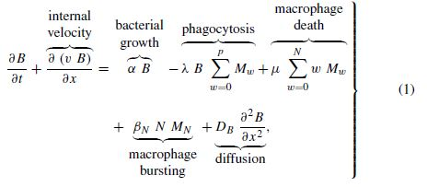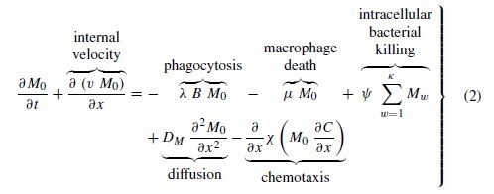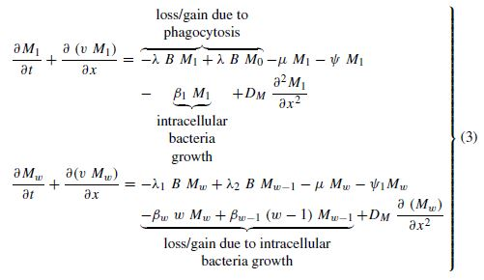
dari persamaan 1, 2 dan 3 dihasilkan grafik seperti gambar 1, gambar 2 dan gambar 3
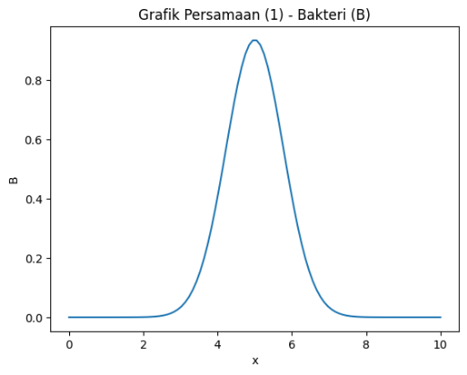  Gambar 1 | 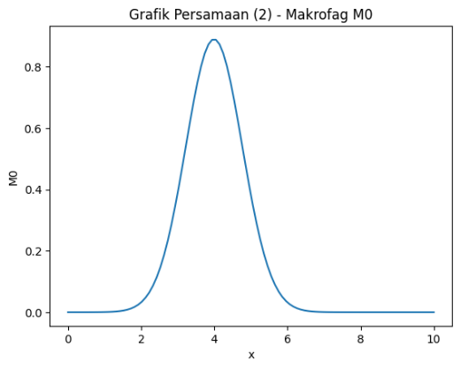  Gambar 2 | 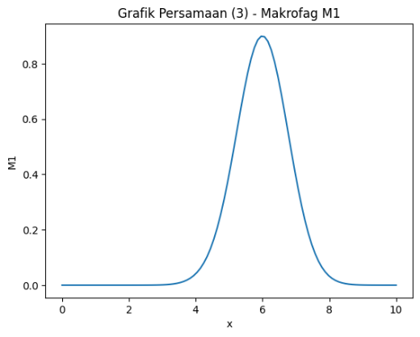  Gambar 3

gambar 3D
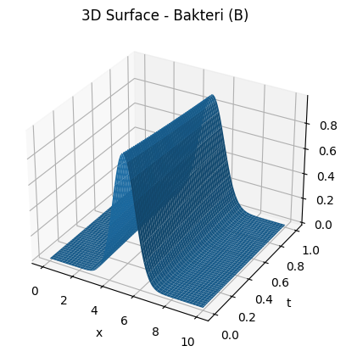  Gambar 1 | 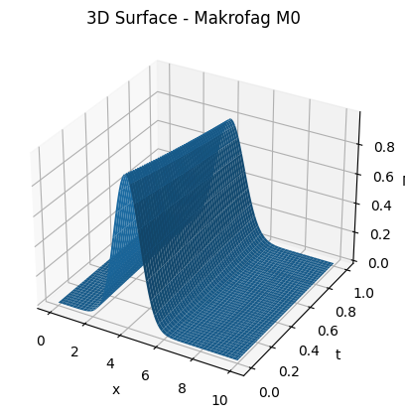  Gambar 2 | 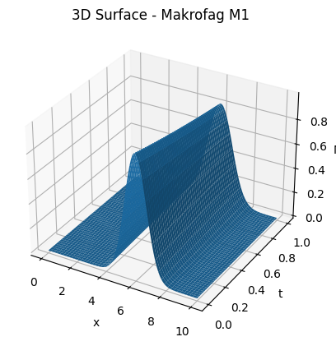  Gambar 3

Berikut script python:
import numpy as np
import matplotlib.pyplot as plt
from mpl_toolkits.mplot3d import Axes3D

# =========================
# 1. GRID SPASIAL & WAKTU
# =========================
x = np.linspace(0, 10, 100) # ruang
t = np.linspace(0, 2, 80) # waktu

dx = x[1] - x[0]
dt = t[1] - t[0]

# =========================
# 2. KONDISI AWAL
# =========================
B = np.exp(-((x - 5)**2)) # bakteri
M0 = np.exp(-((x - 4)**2)) # makrofag awal
M1 = np.exp(-((x - 6)**2)) # makrofag aktif

# =========================
# 3. PARAMETER MODEL
# =========================
alpha = 0.2 # pertumbuhan bakteri
lam = 0.1 # laju fagositosis
mu = 0.05 # kematian makrofag
DB = 0.2 # difusi bakteri
DM = 0.15 # difusi makrofag

# =========================
# 4. OPERATOR LAPLACIAN
# =========================
def laplacian(u):
return (np.roll(u, -1) - 2*u + np.roll(u, 1)) / dx**2

# =========================
# 5. SIMULASI NUMERIK
# =========================
B_hist = []
M0_hist = []
M1_hist = []

for _ in t:
# Simpan kondisi
B_hist.append(B.copy())
M0_hist.append(M0.copy())
M1_hist.append(M1.copy())

# Update persamaan
B_new = B + dt * (alpha*B - lam*B + DB*laplacian(B))
M0_new = M0 + dt * (-lam*B*M0 - mu*M0 + DM*laplacian(M0))
M1_new = M1 + dt * (lam*B*M0 - mu*M1 + DM*laplacian(M1))

B, M0, M1 = B_new, M0_new, M1_new

# Convert ke array
B_hist = np.array(B_hist)
M0_hist = np.array(M0_hist)
M1_hist = np.array(M1_hist)

# Meshgrid untuk plotting
X, T = np.meshgrid(x, t)

# =========================
# 6. PLOT 3D SURFACE
# =========================
def plot_surface(Z, title, zlabel):
fig = plt.figure()
ax = fig.add_subplot(111, projection='3d')

ax.plot_surface(X, T, Z)

ax.set_title(title)
ax.set_xlabel("Ruang (x)")
ax.set_ylabel("Waktu (t)")
ax.set_zlabel(zlabel)

plt.show()

# =========================
# 7. TAMPILKAN GRAFIK
# =========================
plot_surface(B_hist, "3D Surface Bakteri (B)", "B")
plot_surface(M0_hist, "3D Surface Makrofag M0", "M0")
plot_surface(M1_hist, "3D Surface Makrofag M1", "M1")

Persamaan 4:
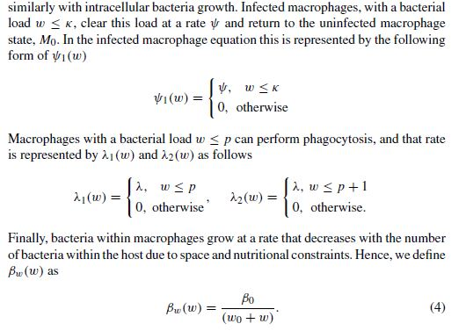
Hasil dari persamaan 4
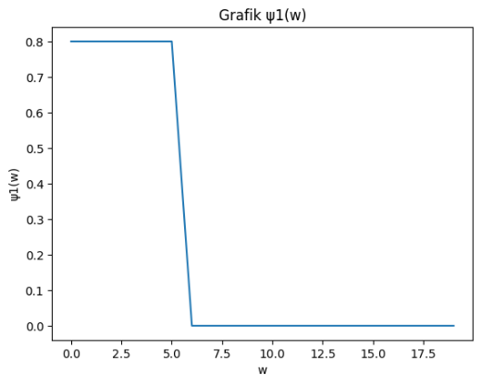  Gambar 4 | 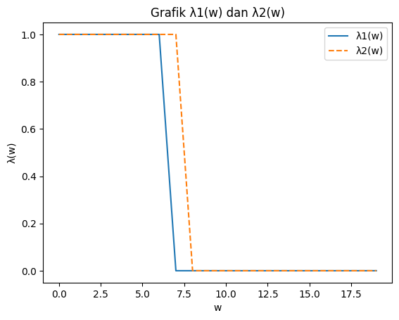  Gambar 5 | 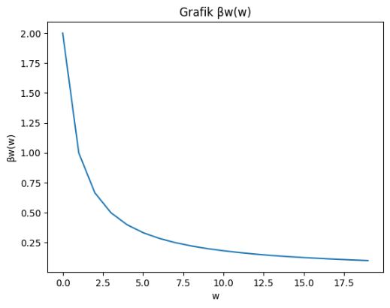  Gambar 6

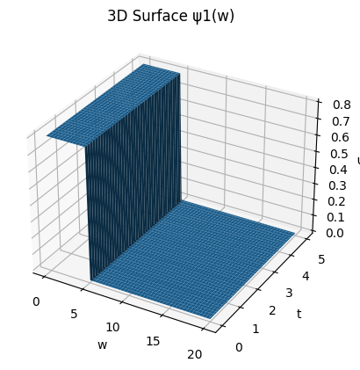  Gambar 4 | 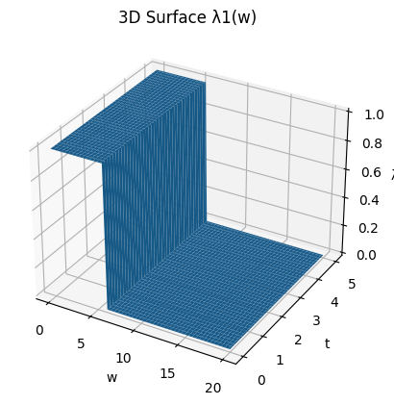  Gambar 5 | 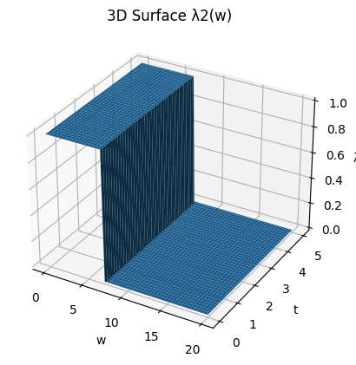  Gambar 6
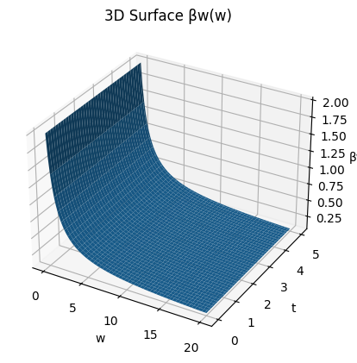
Gambar 7

import numpy as np
import matplotlib.pyplot as plt
from mpl_toolkits.mplot3d import Axes3D

# =========================
# 1. DOMAIN
# =========================
w = np.linspace(0, 20, 100) # jumlah bakteri
t = np.linspace(0, 5, 80) # waktu

W, T = np.meshgrid(w, t)

# =========================
# 2. PARAMETER MODEL
# =========================
k = 5
p = 6
lam = 1.0
psi = 0.8
beta0 = 2.0
w0 = 1.0

# =========================
# 3. DEFINISI FUNGSI
# =========================

# fungsi killing
psi1 = np.where(W <= k, psi, 0)

# fungsi fagositosis
lambda1 = np.where(W <= p, lam, 0)
lambda2 = np.where(W <= p + 1, lam, 0)

# fungsi pertumbuhan
beta_w = beta0 / (w0 + W)

# =========================
# 4. FUNGSI PLOT 3D
# =========================
def plot_3d(Z, title, zlabel):
fig = plt.figure()
ax = fig.add_subplot(111, projection='3d')

ax.plot_surface(W, T, Z)

ax.set_title(title)
ax.set_xlabel("w (jumlah bakteri)")
ax.set_ylabel("t (waktu)")
ax.set_zlabel(zlabel)

plt.show()

# =========================
# 5. VISUALISASI
# =========================
plot_3d(psi1, "3D ψ1(w) - Killing Function", "ψ1(w)")
plot_3d(lambda1, "3D λ1(w) - Phagocytosis", "λ1(w)")
plot_3d(lambda2, "3D λ2(w) - Phagocytosis", "λ2(w)")
plot_3d(beta_w, "3D βw(w) - Growth Function", "βw(w)")

Persamaan 5:
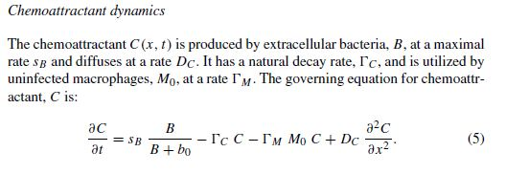
Persamaan 5 2D:
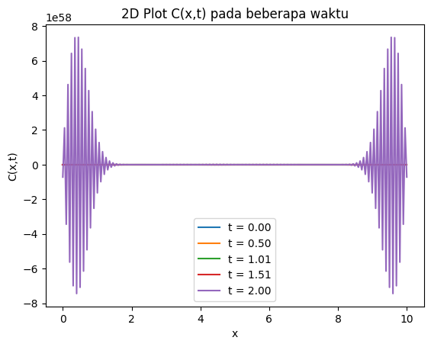
Gambar 8
import numpy as np
import matplotlib.pyplot as plt

# Grid (dibuat lebih stabil)
x = np.linspace(0, 10, 200)
t = np.linspace(0, 1, 200)

dx = x[1] - x[0]
dt = t[1] - t[0]

# Initial condition
C = np.zeros_like(x)
B = np.exp(-((x-5)**2))
M0 = np.exp(-((x-4)**2))

# Parameter
sB = 1.0
b0 = 1.0
GammaC = 0.3
GammaM = 0.2
DC = 0.1 # diturunkan untuk stabilitas

def laplacian(u):
return (np.roll(u, -1) - 2*u + np.roll(u, 1)) / dx**2

# Snapshot waktu
snapshots = []
times_to_plot = [0.1, 0.3, 0.5, 0.8, 1.0]

for ti in t:
if any(abs(ti - tp) < dt for tp in times_to_plot):
snapshots.append((ti, C.copy()))

production = sB * (B / (B + b0))
decay = -GammaC * C
uptake = -GammaM * M0 * C
diffusion = DC * laplacian(C)

C = C + dt * (production + decay + uptake + diffusion)

# Plot 2D
plt.figure()
for ti, snap in snapshots:
plt.plot(x, snap, label=f"t = {ti:.2f}")

plt.title("C(x,t) Stabil (2D)")
plt.xlabel("x")
plt.ylabel("C")
plt.legend()
plt.show()

Persamaan 3 3D:
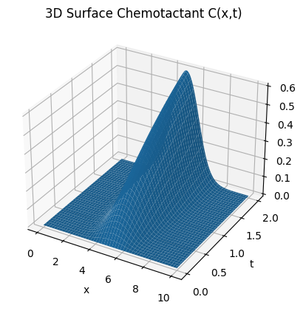
Gambar 9
import numpy as np
import matplotlib.pyplot as plt
from mpl_toolkits.mplot3d import Axes3D

# =========================
# 1. GRID (STABIL)
# =========================
x = np.linspace(0, 10, 150)
t = np.linspace(0, 1, 150)

dx = x[1] - x[0]
dt = t[1] - t[0]

# =========================
# 2. KONDISI AWAL
# =========================
C = np.zeros_like(x)

# Distribusi bakteri & makrofag
B = np.exp(-((x - 5)**2))
M0 = np.exp(-((x - 4)**2))

# =========================
# 3. PARAMETER MODEL
# =========================
sB = 1.0
b0 = 1.0
GammaC = 0.3
GammaM = 0.2
DC = 0.1 # penting untuk stabilitas

# =========================
# 4. LAPLACIAN (DIFUSI)
# =========================
def laplacian(u):
return (np.roll(u, -1) - 2*u + np.roll(u, 1)) / dx**2

# =========================
# 5. SIMULASI
# =========================
C_hist = []

for _ in t:
C_hist.append(C.copy())

production = sB * (B / (B + b0))
decay = -GammaC * C
uptake = -GammaM * M0 * C
diffusion = DC * laplacian(C)

C = C + dt * (production + decay + uptake + diffusion)

C_hist = np.array(C_hist)

# =========================
# 6. VISUALISASI 3D
# =========================
X, T = np.meshgrid(x, t)

fig = plt.figure()
ax = fig.add_subplot(111, projection='3d')

ax.plot_surface(X, T, C_hist)

ax.set_title("3D Surface Chemotactant C(x,t)")
ax.set_xlabel("x (ruang)")
ax.set_ylabel("t (waktu)")
ax.set_zlabel("C(x,t)")

plt.show()

Persamaan 6 dan 7:
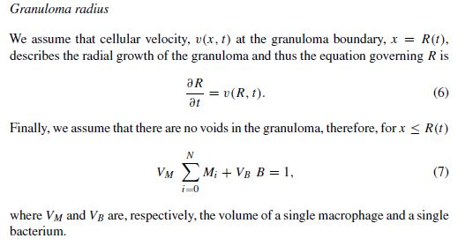
Hasil dari persamaan
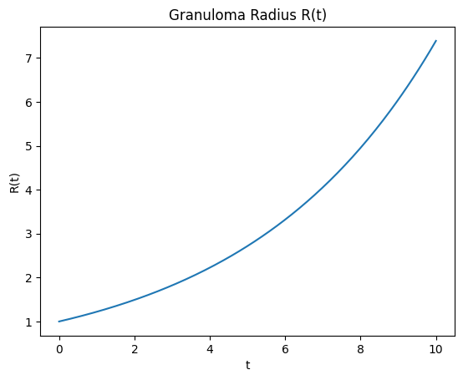  Gambar 10 | 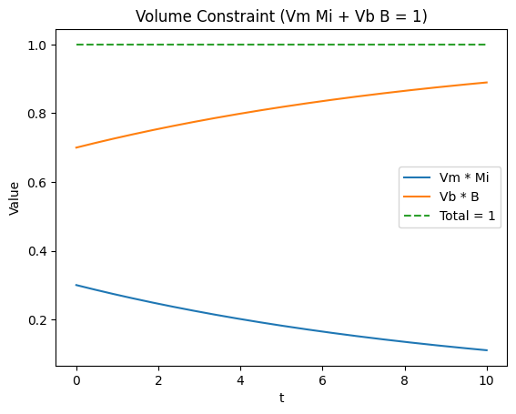  Gambar 11

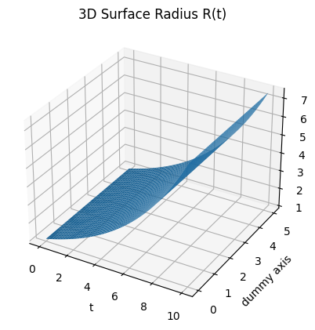  Gambar 10 | 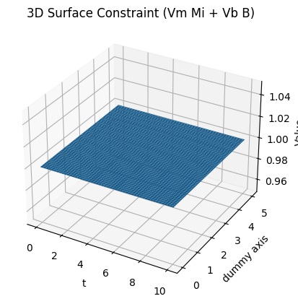  Gambar 11

import numpy as np
import matplotlib.pyplot as plt
from mpl_toolkits.mplot3d import Axes3D

# =========================
# 1. DOMAIN
# =========================
t = np.linspace(0, 10, 150) # waktu
y = np.linspace(0, 5, 100) # dummy axis (untuk surface)

T, Y = np.meshgrid(t, y)

# =========================
# 2. MODEL RADIUS R(t)
# =========================
# Model realistis (logistic growth, lebih baik dari eksponensial)
R_max = 10
k = 0.5
R0 = 1

R = R_max / (1 + ((R_max - R0)/R0) * np.exp(-k * T))

# =========================
# 3. MODEL POPULASI
# =========================
# Makrofag menurun
M = 0.6 * np.exp(-0.2 * T)

# Volume parameter
Vm = 0.6
Vb = 0.4

# Bakteri dari constraint
B = (1 - Vm * M) / Vb

# Constraint total
constraint = Vm * M + Vb * B

# =========================
# 4. PLOT 3D R(t)
# =========================
fig = plt.figure()
ax = fig.add_subplot(111, projection='3d')

ax.plot_surface(T, Y, R)

ax.set_title("3D Radius Granuloma R(t)")
ax.set_xlabel("Waktu (t)")
ax.set_ylabel("Dimensi tambahan")
ax.set_zlabel("Radius R")

plt.show()

# =========================
# 5. PLOT 3D CONSTRAINT
# =========================
fig = plt.figure()
ax = fig.add_subplot(111, projection='3d')

ax.plot_surface(T, Y, constraint)

ax.set_title("3D Constraint Volume (Vm M + Vb B = 1)")
ax.set_xlabel("Waktu (t)")
ax.set_ylabel("Dimensi tambahan")
ax.set_zlabel("Nilai")

plt.show()

Persamaan 8:
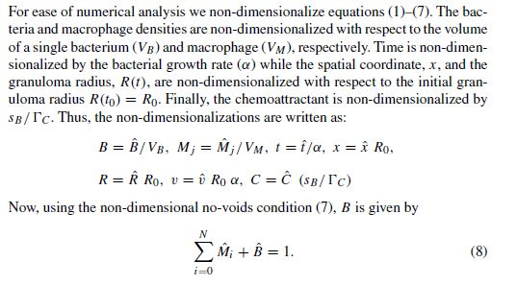
Hasil dari persamaan
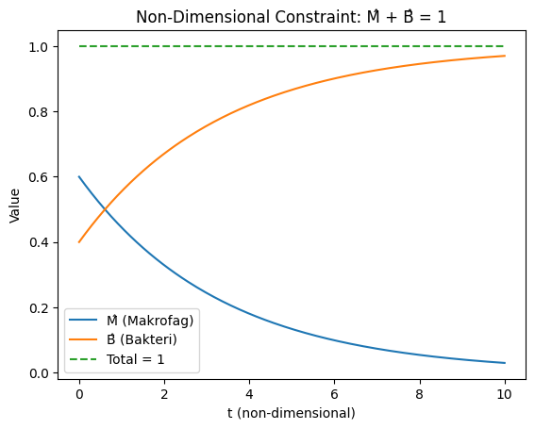  Gambar 12 | 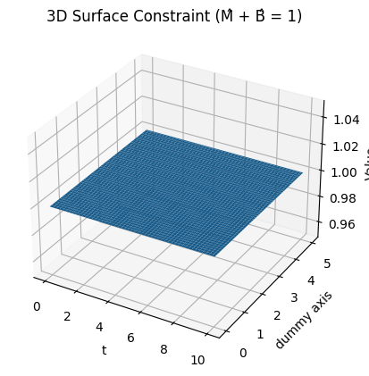  Gambar 12

import numpy as np
import matplotlib.pyplot as plt
from mpl_toolkits.mplot3d import Axes3D

# =========================
# 1. DOMAIN WAKTU
# =========================
t = np.linspace(0, 10, 200)

# =========================
# 2. MODEL NON-DIMENSI
# =========================
# Makrofag (menurun)
M_hat = 0.6 * np.exp(-0.3 * t)

# Bakteri (dari constraint)
B_hat = 1 - M_hat

# =========================
# 3. GRAFIK 2D
# =========================
plt.figure()

plt.plot(t, M_hat, label="M̂ (Makrofag)")
plt.plot(t, B_hat, label="B̂ (Bakteri)")
plt.plot(t, M_hat + B_hat, '--', label="Total = 1")

plt.title("Non-Dimensional Constraint: M̂ + B̂ = 1")
plt.xlabel("t (non-dimensional)")
plt.ylabel("Value")
plt.legend()

plt.show()

# =========================
# 4. GRAFIK 3D
# =========================
y = np.linspace(0, 5, 100) # dummy axis
T, Y = np.meshgrid(t, y)

# Extend ke 3D
M_surface = 0.6 * np.exp(-0.3 * T)
B_surface = 1 - M_surface
Total_surface = M_surface + B_surface

# Plot 3D
fig = plt.figure()
ax = fig.add_subplot(111, projection='3d')

ax.plot_surface(T, Y, Total_surface)

ax.set_title("3D Surface Constraint (M̂ + B̂ = 1)")
ax.set_xlabel("t")
ax.set_ylabel("Dimensi tambahan")
ax.set_zlabel("Value")

plt.show()

Persamaan 9:
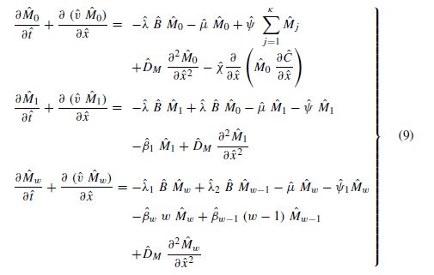
Hasil dari persamaan
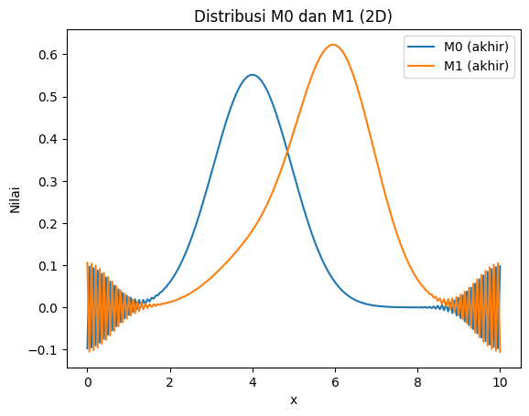
Gambar 13

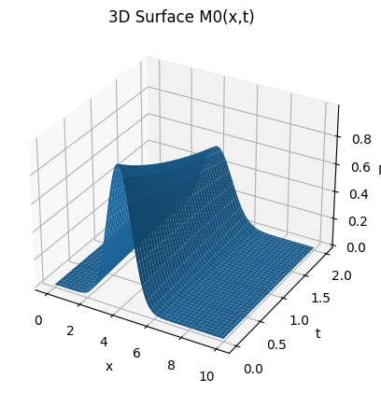  Gambar 13 M0 | 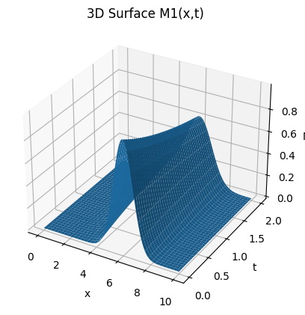  Gambar 13 M1

import numpy as np
import matplotlib.pyplot as plt
from mpl_toolkits.mplot3d import Axes3D

# =========================
# 1. GRID
# =========================
L = 10
Nx = 120
Nt = 150

x = np.linspace(0, L, Nx)
t = np.linspace(0, 2, Nt)

dx = x[1] - x[0]
dt = t[1] - t[0]

X, T = np.meshgrid(x, t)

# =========================
# 2. KONDISI AWAL
# =========================
M0 = np.exp(-((x - 4)**2)) # makrofag sehat
M1 = np.exp(-((x - 6)**2)) # makrofag terinfeksi

# bakteri (diasumsikan tetap untuk sederhana)
B = np.exp(-((x - 5)**2))

# =========================
# 3. PARAMETER MODEL
# =========================
lam = 0.15 # infeksi
mu = 0.05 # kematian
beta1 = 0.05 # degradasi M1
DM = 0.1 # difusi

# =========================
# 4. OPERATOR DIFUSI
# =========================
def laplacian(u):
return (np.roll(u, -1) - 2*u + np.roll(u, 1)) / dx**2

# =========================
# 5. SIMULASI
# =========================
M0_hist = []
M1_hist = []

for _ in t:
M0_hist.append(M0.copy())
M1_hist.append(M1.copy())

# ===== Persamaan M0 =====
dM0 = (
- lam * B * M0
- mu * M0
+ DM * laplacian(M0)
)

# ===== Persamaan M1 =====
dM1 = (
+ lam * B * M0
- mu * M1
- beta1 * M1
+ DM * laplacian(M1)
)

# update
M0 = M0 + dt * dM0
M1 = M1 + dt * dM1

# ubah ke array
M0_hist = np.array(M0_hist)
M1_hist = np.array(M1_hist)

# =========================
# 6. PLOT 3D M0
# =========================
fig = plt.figure()
ax = fig.add_subplot(111, projection='3d')

ax.plot_surface(X, T, M0_hist)

ax.set_title("3D Surface M0(x,t)")
ax.set_xlabel("x")
ax.set_ylabel("t")
ax.set_zlabel("M0")

plt.show()

# =========================
# 7. PLOT 3D M1
# =========================
fig = plt.figure()
ax = fig.add_subplot(111, projection='3d')

ax.plot_surface(X, T, M1_hist)

ax.set_title("3D Surface M1(x,t)")
ax.set_xlabel("x")
ax.set_ylabel("t")
ax.set_zlabel("M1")

plt.show()

Persamaan 10, 11 dan 12:
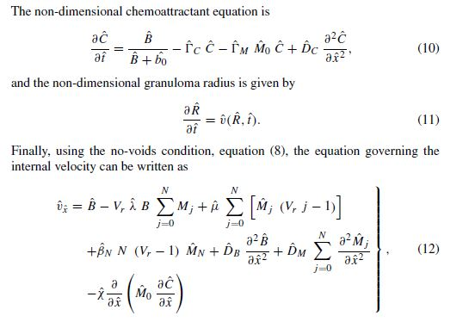
Hasil dari persamaan
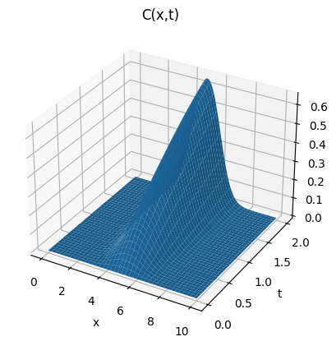
Gambar 14
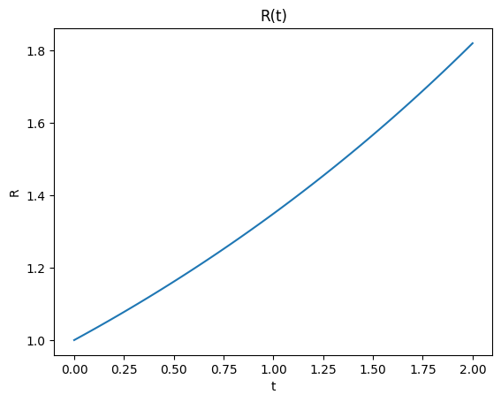
Gambar 15
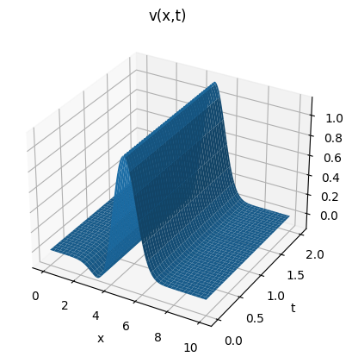
Gambar 16

import numpy as np
import matplotlib.pyplot as plt
from mpl_toolkits.mplot3d import Axes3D

# =========================
# 1. GRID
# =========================
L = 10
Nx = 120
Nt = 150

x = np.linspace(0, L, Nx)
t = np.linspace(0, 2, Nt)

dx = x[1] - x[0]
dt = t[1] - t[0]

X, T = np.meshgrid(x, t)

# =========================
# 2. KONDISI AWAL
# =========================
C = np.zeros_like(x)
B = np.exp(-((x - 5)**2))
M0 = np.exp(-((x - 4)**2))

# =========================
# 3. PARAMETER NON-DIMENSI
# =========================
b0 = 1.0
GammaC = 0.3
GammaM = 0.2
DC = 0.1

# radius
R = 1.0
kR = 0.4

# velocity parameter
vr = 0.2
chi = 0.1
DB = 0.05
DM = 0.05

# =========================
# 4. OPERATOR DIFUSI
# =========================
def laplacian(u):
return (np.roll(u, -1) - 2*u + np.roll(u, 1)) / dx**2

def gradient(u):
return np.gradient(u, dx)

# =========================
# 5. STORAGE
# =========================
C_hist = []
R_hist = []
v_hist = []

# =========================
# 6. SIMULASI
# =========================
for _ in t:
# simpan
C_hist.append(C.copy())
R_hist.append(R)

# ===== (10) CHEMOATTRACTANT =====
production = B / (B + b0)
decay = -GammaC * C
uptake = -GammaM * M0 * C
diffusion = DC * laplacian(C)

C = C + dt * (production + decay + uptake + diffusion)

# ===== (11) RADIUS =====
dR = kR * R
R = R + dt * dR

# ===== (12) VELOCITY (SIMPLIFIED) =====
gradC = gradient(C)
gradM0 = gradient(M0)

v = (
B
- vr * B * M0
+ DB * laplacian(B)
+ DM * laplacian(M0)
- chi * gradient(M0 * gradC)
)

v_hist.append(v)

# ubah ke array
C_hist = np.array(C_hist)
R_hist = np.array(R_hist)
v_hist = np.array(v_hist)

# =========================
# 7. PLOT 3D C(x,t)
# =========================
fig = plt.figure()
ax = fig.add_subplot(111, projection='3d')

ax.plot_surface(X, T, C_hist)

ax.set_title("3D Chemoattractant C(x,t)")
ax.set_xlabel("x")
ax.set_ylabel("t")
ax.set_zlabel("C")

plt.show()

# =========================
# 8. PLOT R(t)
# =========================
plt.figure()
plt.plot(t, R_hist)

plt.title("Granuloma Radius R(t)")
plt.xlabel("t")
plt.ylabel("R")

plt.show()

# =========================
# 9. PLOT 3D VELOCITY v(x,t)
# =========================
fig = plt.figure()
ax = fig.add_subplot(111, projection='3d')

ax.plot_surface(X, T, v_hist)

ax.set_title("3D Internal Velocity v(x,t)")
ax.set_xlabel("x")
ax.set_ylabel("t")
ax.set_zlabel("v")

plt.show()

Persamaan 13:
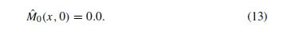
Hasil dari persamaan
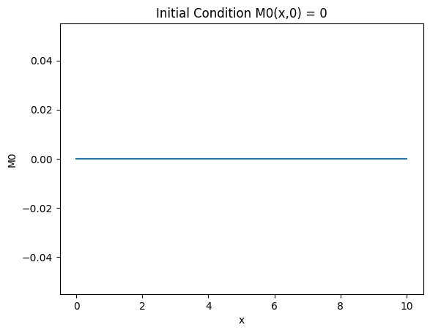  Gambar 17 | 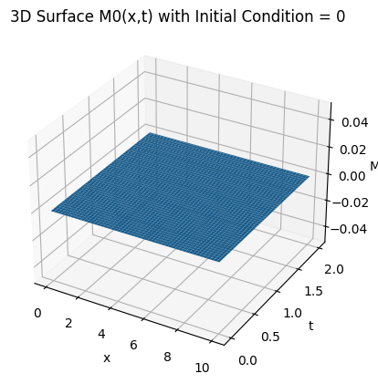  Gambar 17

import numpy as np
import matplotlib.pyplot as plt
from mpl_toolkits.mplot3d import Axes3D

# =========================
# 1. DOMAIN
# =========================
x = np.linspace(0, 10, 200) # ruang
t = np.linspace(0, 2, 100) # waktu

# =========================
# 2. KONDISI AWAL
# =========================
M0 = np.zeros_like(x) # M0(x,0) = 0

# =========================
# 3. PLOT 2D
# =========================
plt.figure()
plt.plot(x, M0)

plt.title("Kondisi Awal: M0(x,0) = 0")
plt.xlabel("x (ruang)")
plt.ylabel("M0")

plt.grid()
plt.show()

# =========================
# 4. PLOT 3D (EXTENSION)
# =========================
X, T = np.meshgrid(x, t)
M0_surface = np.zeros_like(X)

fig = plt.figure()
ax = fig.add_subplot(111, projection='3d')

ax.plot_surface(X, T, M0_surface)

ax.set_title("3D Surface M0(x,t) dengan M0(x,0)=0")
ax.set_xlabel("x")
ax.set_ylabel("t")
ax.set_zlabel("M0")

plt.show()

Persamaan 14:
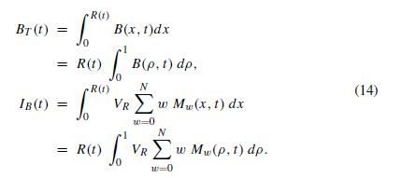

Hasil persamaan
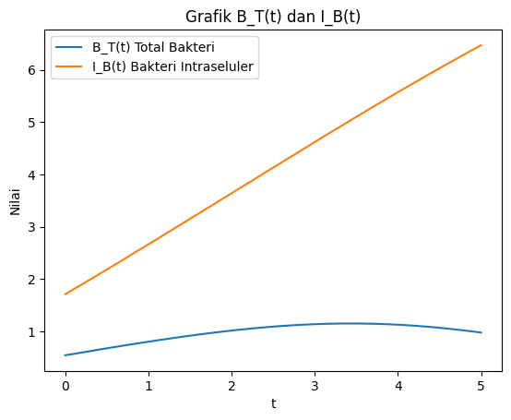
Gambar 18

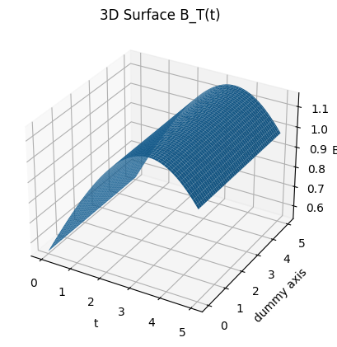  Gambar 18 B_T(T) | 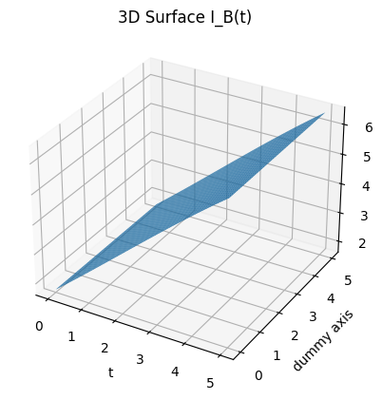  Gambar 18 I_B(T)

import numpy as np
import matplotlib.pyplot as plt
from mpl_toolkits.mplot3d import Axes3D

# =========================
# 1. DOMAIN
# =========================
t = np.linspace(0, 5, 150)
y = np.linspace(0, 5, 80) # dummy axis untuk 3D

T, Y = np.meshgrid(t, y)

# =========================
# 2. PARAMETER
# =========================
VR = 0.5
N = 3

# =========================
# 3. FUNGSI MODEL
# =========================

# Radius granuloma
def R_func(t):
return 1 + 0.5 * t

# Distribusi bakteri
def B_func(rho, t):
return np.exp(-((rho - 0.5 - 0.1*t)**2) * 10)

# Distribusi makrofag terinfeksi
def Mw_func(rho, t, w):
return np.exp(-((rho - 0.3 - 0.05*t)**2) * (5 + w))

# =========================
# 4. GRID INTEGRASI
# =========================
rho = np.linspace(0, 1, 100)

# =========================
# 5. HITUNG BT dan IB
# =========================
BT_surface = np.zeros_like(T)
IB_surface = np.zeros_like(T)

for i in range(T.shape[0]):
for j in range(T.shape[1]):
ti = T[i, j]

# ===== BT =====
B_vals = B_func(rho, ti)
BT_surface[i, j] = R_func(ti) * np.trapz(B_vals, rho)

# ===== IB =====
Mw_sum = np.zeros_like(rho)
for w in range(N+1):
Mw_sum += w * Mw_func(rho, ti, w)

IB_surface[i, j] = R_func(ti) * VR * np.trapz(Mw_sum, rho)

# =========================
# 6. PLOT 3D BT
# =========================
fig = plt.figure()
ax = fig.add_subplot(111, projection='3d')

ax.plot_surface(T, Y, BT_surface)

ax.set_title("3D Surface B_T(t)")
ax.set_xlabel("t")
ax.set_ylabel("Dimensi tambahan")
ax.set_zlabel("B_T")

plt.show()

# =========================
# 7. PLOT 3D IB
# =========================
fig = plt.figure()
ax = fig.add_subplot(111, projection='3d')

ax.plot_surface(T, Y, IB_surface)

ax.set_title("3D Surface I_B(t)")
ax.set_xlabel("t")
ax.set_ylabel("Dimensi tambahan")
ax.set_zlabel("I_B")

plt.show()

